**WKKC Salutes Revell Harper,   
Host of Thursday Night Steppin’!  
Gone but not forgotten!**

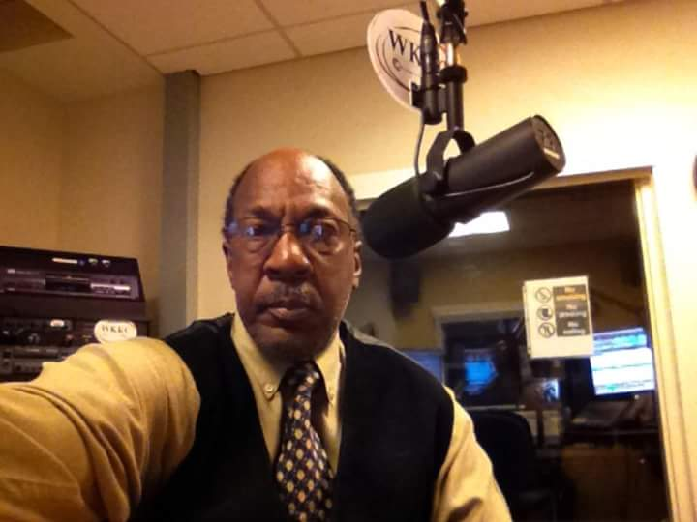

**Revell Harper’s Home Going Service**

Thursday, January 31, 2019  
Lay In State 3pm – 6pm  
Acklin Funeral Home, 1325 West 87th Street, Chicago

Friday, February 1, 2019  
Repast: 9:00am  
Wake: 10:00am  
Funeral: 10:30am  
Lacrosse Assembly of God, 10833 South Halsted Street, Chicago, IL

Full Military Honors at Abraham Lincoln Memorial Cemetery, 20053 West Hoff Road, Elwood, IL 60421