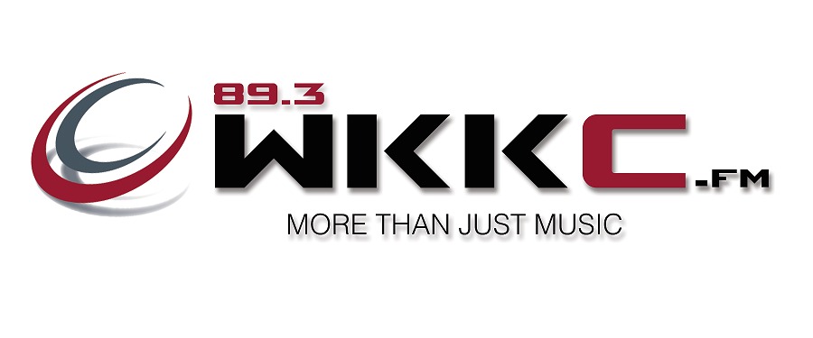**WKKC National Artists Playlist (week of 01/17/17)   
Official Radio Station of City Colleges of Chicago.   
“Chicago’s Most Popular College Music Radio Station”**Greg Murray – Program Director – 773-602-5587 – [gmurray9@ccc.edu](mailto:gmurray9@ccc.edu)  
Marcella Jones – Assistant Program Director/Music Director  
WKKC-FM & HD1; also available on the net at [www.WKKC.FM](http://www.WKKC.FM) and with The Free Tunein App.  
**WKKC 89.3FM/HD1/HD2 Chicago is located on the campus of Kennedy-King College, 740 West 63rd Street, Chicago, IL 60621. City Colleges of Chicago.**  
Symbolisms: TW = This Week’s Position | LW = Last Week’s Position | * = Increased or Stayed in position over Last Week **| Bold = New or Returned to chart This Week** | -- = No Data or Returned to chart this week  
  
**TW LW Loc Title Artist(s) Label**  
01* 01 CC695 Black Beatles Rae Sremmurd ft. Gucci Mane Ear Drummer/Interscope  
02* 03 CC708 Fake Love Drake YMCMB/Republic  
03 02 CC687 Thick Of It Mary J. Blige Capitol  
04* 04 CC670 So I Can Have Back Joe Plaid Takeover  
05* 08 CC690 Caroline Amine Republic  
06* 07 CC664 1990x Maxwell Columbia  
07* 10 CC669 OTW (On The Way) DJ Luke Nasty Othaz Records/Empire  
08* 09 CC570 Permission Ro James ByStorm/RCA  
09* 14 CC698 Love On The Brain Rihanna Westbury Road/Roc Nation  
10* 11 CC710 Why I Love You Major. BOE/Impire  
11 05 CC667 Come And See Me PartyNextDoor feat Drake OVO Sound/Warner Brothers  
12 06 CC681 Side To Side Ariana Grande feat Nicki Minaj Republic  
13* 13 CC677 Long Song Away Kevin Ross Motown/Capitol  
14 12 CC682 Starboy The Weekend feat Daft Punk XO/Republic  
15* 17 CC616 Lake By The Ocean Maxwell Columbia  
16* 18 CC713 Bounce Back Big Sean Def Jam  
17* 21 CC688 Love Me Now John Legend Columbia  
18* 19 CC704 Not Nice PartyNextDoor OVO Sound/Warner Brothers  
19* 20 CC680 Run Bel Biv DeVoe (BBD) eOne  
20* 23 CC716 I Feel It Coming The Weekend feat Daft Punk XO/Republic  
21* 24 CC706 Don’t Want You Back Leela James J&T Records/BMG  
22* 28 CC721 Use To This Future feat Drake FreeBandz/A-1/Epic  
23 16 CC693 24K Magic Bruno Mars Atlantic  
24 15 CC678 Missin U Usher RCA  
25* 26 CC711 Push It On Me Trey Songz Motown/Capitol  
26* 32 CC723 Party Monster The Weekend XO/Republic  
27* 27 CC712 Best Love Yuna Fader Label  
28 25 CC705 Sex With Me Rihanna Westbury Road/Roc Nation  
29 22 CC696 Blended Family (What You Do For Love) Alicia Keys ft. A$ap Rocky RCA  
30* 31 CC714 Insane Eric Benet Primary Wave  
31 30 CC718 Location Khalid RightHandMusicGroup/RCA  
32 29 CC700 Good Woman La’Porsha Renae Motown/Capitol  
33* 33 CC699 Cranes In The Sky Solange Saint Records/Columbia  
34* 34 CC728 Come Do Nothing Avery*Sunshine Big Shine/Shanachie  
35* 35 CC719 Redbone Childish Gamino Glassnote  
36* 41 CC729 I’m Blessed (Plus a Remix CC729x) Charlie Wilson P Music Group/RCA  
37 36 CC717 All Night Beyonce Columbia  
38* 38 CA541 Dancing With The Stars (Dwts) Steve “Stone” Huff Billionaires/EMPIRE  
**39* NEW CC731 Surrender Lalah Hathaway & Pharrell Williams Columbia  
40* NEW CC732 Déjà vu J. Cole DreamVille/Roc Nation**41 39 CC701 Close To You Dreezy ft T-Pain Interscope  
42 40 CC697 Already Knew That Ro James ByStorm/RCA  
**43* NEW CC733 Never Know Kindred The Family Soul Were Not A Label**44 42 CC658 LUV Tory Lanez MadLove/Interscope  
45* 46 CC730 Round Whippin’ A.Chal Gazi World/EMPIRE  
46 45 CC725 Cash Machine D.R.A.M. W.A.V.E./RRP/EMPIRE  
47* 49 CC639 Controlla Drake YMCMB/Republic  
48 47 CC673 Hold Up Beyonce Columbia  
49 44 CC660 Tru Lloyd Young Goldie/EMPIRE  
50 43 CC724 Erbody But Me Tech N9NE ft. Bizzy & Kriss Kaliko Strange Music  
  
  
  
  
  
 **\*Loc = Location in our Systems Library**